**Data Structures and Algorithms**

**Question one**

#include<iostream>using namespace std;int main ()

{ char a = 700; char b = -129; char c = +200; short e =66000; short f = -32769; short g = + 40000; int h = 4500000000; int i = +2147483650; int j = -2147483655;cout<<a<<"\n"<<b<<"\n"<<c<<"\n"<<e<<"\n"<<f<<"\n"<<g<<"\n"<<h<<"\n"<<i<<"\n"<<j<<"\n";return 0;}

**Explanation**

The values assigned to the data types Char, Short and Int (unsigned and signed) show either an underflow or an overflow from the range of values assigned to the datatypes. When the values surpass the limit, an overflow is reflected. When they go below the limit, an underflow is reflected.

According to the source code,

The signed Char values have exceeded the -128 to +127 range

The unsigned Char values exceeded the 0 to 255 range

Data type char variables exceeded the following ranges:

unsigned char 0 to 255

signed char -127 to 127

The assigned variables of datatype int exceeded the following ranges:

unsigned int 0 to 4294967295

signed int -2147483648 to 2147483647

The assigned variables of datatype short exceeded the following ranges:

unsigned short int 0 to 65,535

signed short int -32768 to 3276

**Question two**

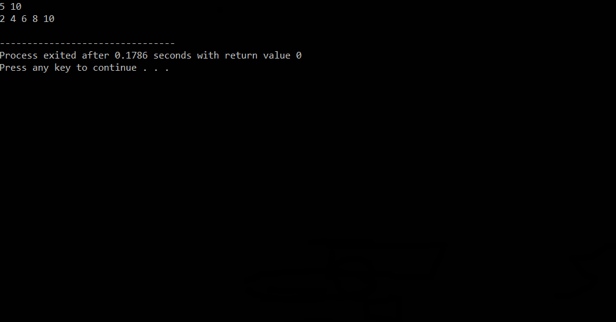

The output is as above for we are using a for loop that sets n to 0 each time you call print array.

Print array will print the length of any array that you pass it as long as length is less than or equal to the size of the array.

After we set the length of the first array to two the output was the first two elements (5,10) of the first array.

We then set the length of the second array to five and the output was the first five elements (2,4,6,8,10) of the second array.

**Group members:**

131440-Jeff Mwangi.

134333-Kariuki Patience.

133482- Maureen Nd’ung’u.

131083- Ignatius Ng’ang’a.

134554-Sharon Mutithu.